UI Verification

**Batch:8**

**Module 7 Assignment**

**Submitted By: Sadia Akter Sinthia**

**Answer to the question no. 4**

**Q4|** Now there is a happy path journey for searching with the text “Nike react phantom run flyknit 2”. Add a couple of small-sized black products to your cart. Then verify the Cart. Now execute the journeys from both API and UI. Now provide feedback on your test analysis, keep logs of the defects, and generate a report.

**Answer:**

### **Product Searching By Name**

***UI Verification :***

* **Steps:**

Navigate to the product search bar

Searched by product names

* **Expected Result:**

If the product name matches then the product should be shown in the UI.

* **Actual Result:**

Product displayed in the UI.

* **Status:**

200 OK. (Passed)

* **Snapshot:**

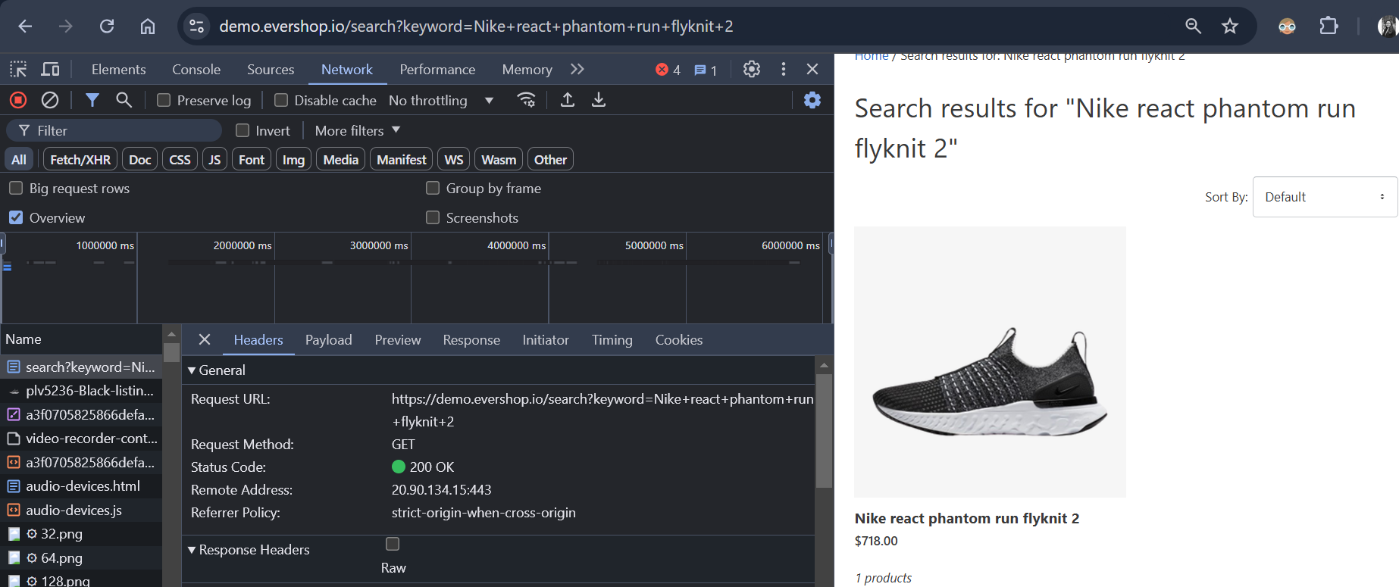

***API Verification by Postman:***

* API :

<https://demo.evershop.io/search?keyword=Nike+react+phantom+run+flyknit+2&ajax=true>

* **Method :** Get
* **Parameters** : 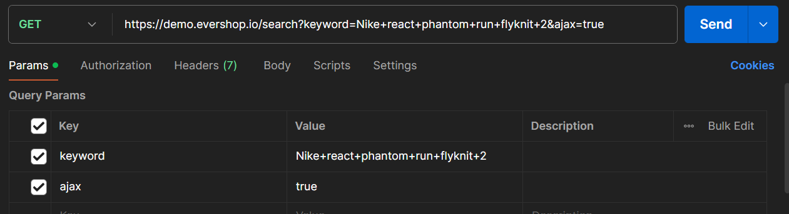
* **Expected result** : API should return the product details according to product name and 200 status code.
* **Actual Result:** Product details returned successfully with status code
* **Status :** 200 OK . (passed)

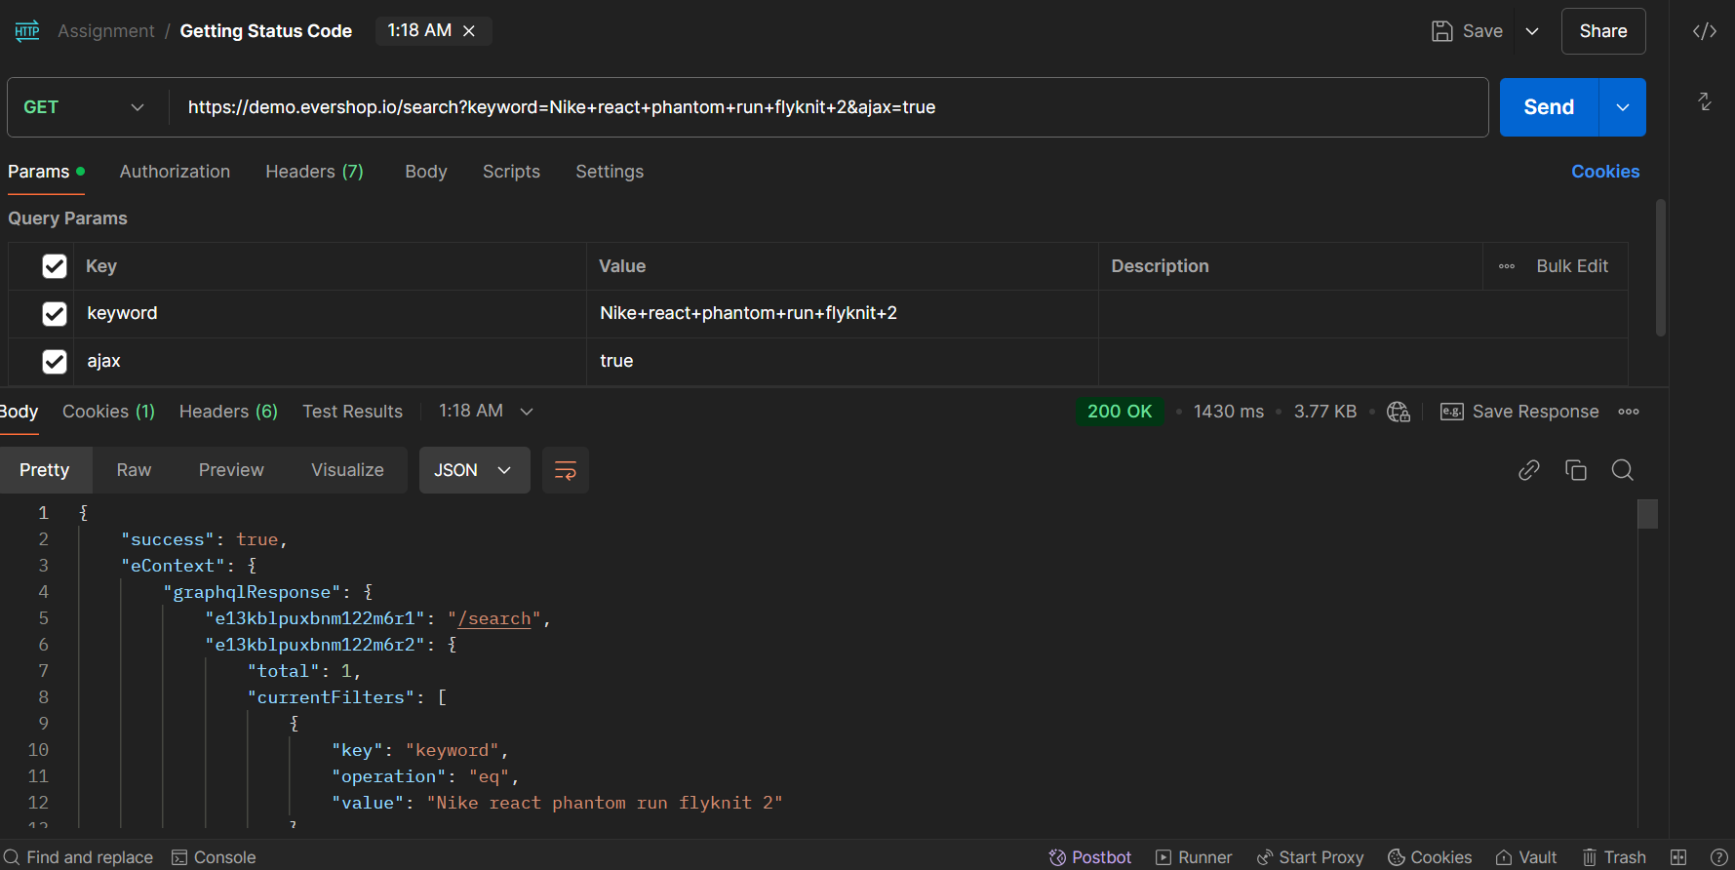

* ***Analysis :*** No error found in both UI and API end.

### **Adding Product to Cart**

***UI Verification :***

* **Steps:**

Open to product detail page.

Clicking on product size ‘s’ and color ‘black’ button to select.

Add the quantity of the product by typing the quantity panel.

Click on the ‘Add to cart’ button.

* **Expected Result:**

All information should be available to the product detail page.

Product size and color should be selected frequently

Quantity can be increase and decrease frequently

By clicking on ‘Add to cart’ button product a popup or alert should show that product is added.

* **Actual Result:**

All information was available to the product detail page.

Product size and color was selected frequently by clicking on selective buttons

Quantity was increased and decreased frequently

A pop up showed a message that the product is added.

* **Status:**

200 OK. (Passed)

* **Snapshot:**

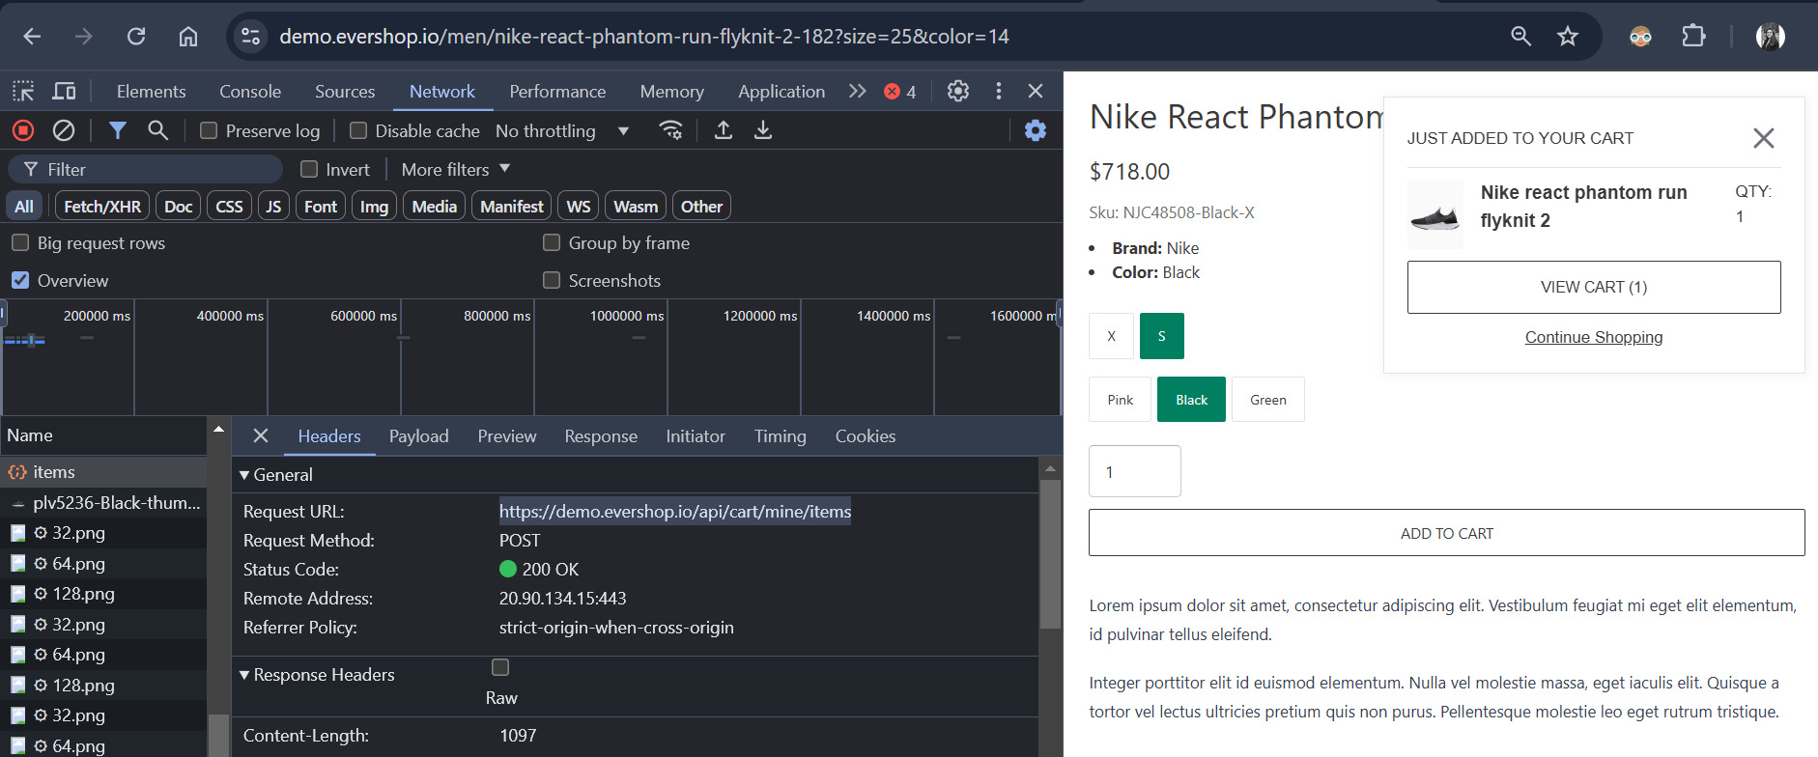

***API Verification by Postman:***

* **API :**

<https://demo.evershop.io/api/cart/mine/items>

* **Method :** POST
* **Headers:**
* **Cookie**: sid=s%3AbJTg45BC575DPs16kR1m71jV6Mp0GMZO.m%2Ft0dIVM%2FCA0d2HAkfbw2zjrAnGyWpw4cC%2FWzuNaRis; SL_G_WPT_TO=en; SL_GWPT_Show_Hide_tmp=1; SL_wptGlobTipTmp=1
* **Body:**

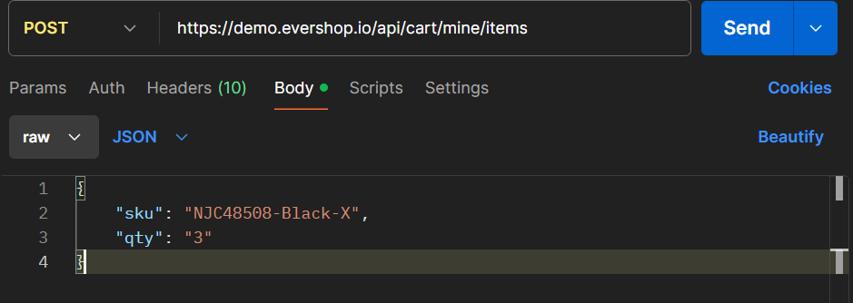

* **Expected Result:**
* Status code 200
* Quantity should be increased
* Response body should be shown that the product is added to the cart by increasing the quantity number and and prize.
* **Actual Result**
* Status code 200 OK showed
* Quantity was increased frequently
* Response body should show that the product is added to the cart by increasing the quantity number and and prize.
* **Status:** 200 OK. (Passed)

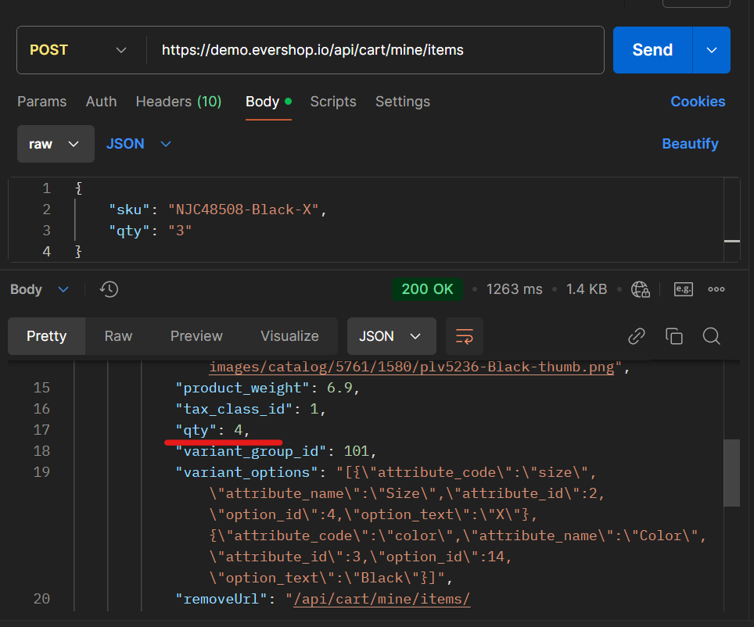

* ***Analysis :*** Both UI and API added increased quantity product successfully no error found.

### **Verify Cart**

***UI Verification :***

* **Steps:**

Click on the “Cart” icon.

* **Expected Result:**

Navigate to the product cart by clicking on the “Cart” icon.

Product details should appear in the cart with details like quantity, prize.

* **Actual Result:**

Navigated to the product cart by clicking on the “Cart” icon.

Product details appeared in the cart with details like quantity , prize.

* **Status:**

200 OK. (Passed).

* **Snapshot**

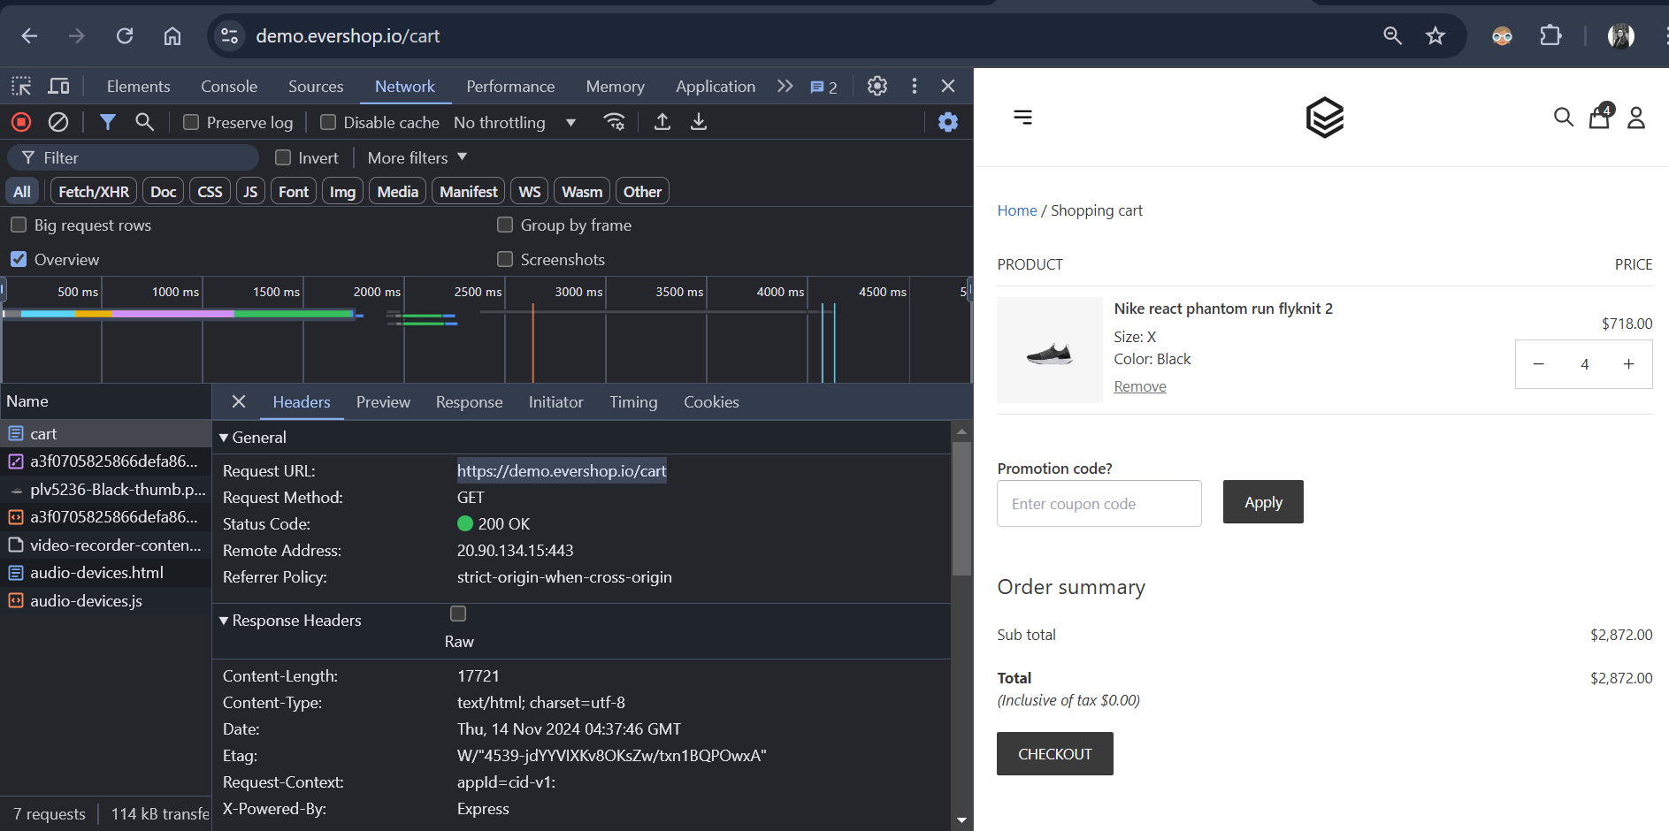

***API Verification by Postman:***

* **API:**

<https://demo.evershop.io/cart>

* **Method:** GET
* **Headers**
* **Cookie:**

Hsid=s%3AbJTg45BC575DPs16kR1m71jV6Mp0GMZO.m%2Ft0dIVM%2FCA0d2HAkfbw2zjrAnGyWpw4cC%2FWzuNaRis; SL_G_WPT_TO=en; SL_GWPT_Show_Hide_tmp=1; SL_wptGlobTipTmp=1eaders:

* **Expected Result:**
* Status code 200.
* Response body should show correct details of the product.
* **Actual Result:**
* Status code 200 showed.
* Response body showed correct details of the product.
* **Status :** 200 OK. ( Passed)

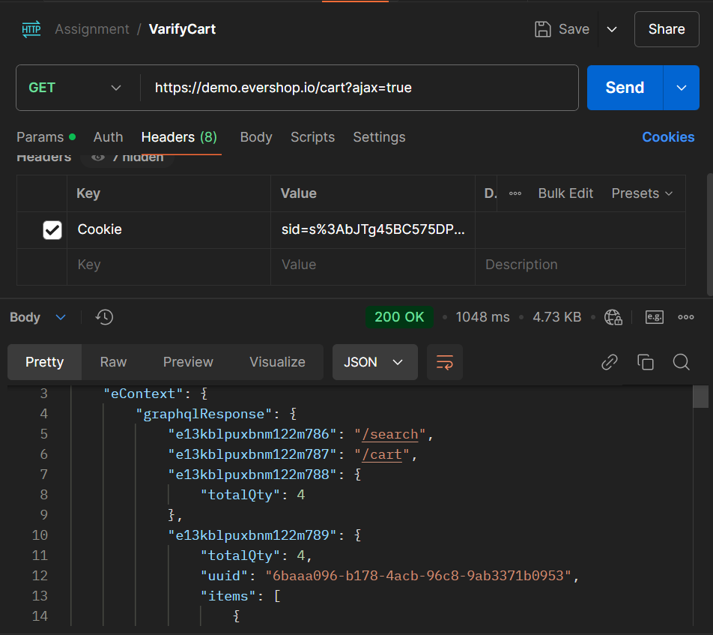

* ***Analysis :*** No error found.

### **Adding Limitless Product to the Cart**

***UI Verification :***

* **Steps:**

Type product quantity to the quantity panel.

* **Expected Result:**

Limitless products can not be added to carts.

* **Actual Result:**

Limitless products were not able to be added to cart.

* **Status:**

500 Internal Server Error. (Failed).

* **Snapshot:**

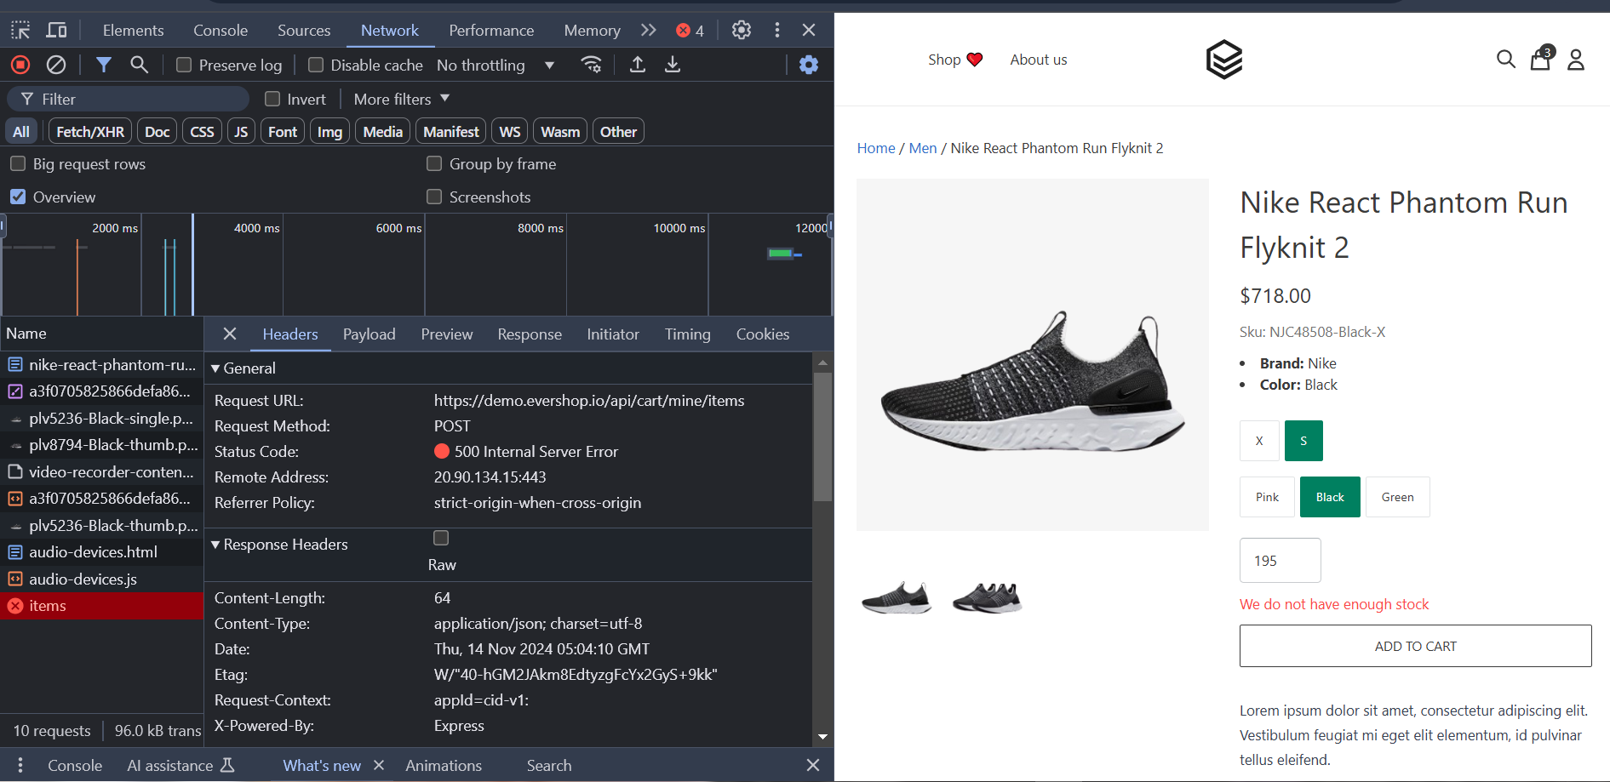

***API Verification by Postman:***

* API:

<https://demo.evershop.io/api/cart/mine/items>

* **Method:** POST
* **Headers**
* **Cookie:**

Hsid=s%3AbJTg45BC575DPs16kR1m71jV6Mp0GMZO.m%2Ft0dIVM%2FCA0d2HAkfbw2zjrAnGyWpw4cC%2FWzuNaRis; SL_G_WPT_TO=en; SL_GWPT_Show_Hide_tmp=1; SL_wptGlobTipTmp=1eaders:

* **Expected Result:**
* Status code 500.
* Error Message should display.
* **Actual Result:**
* Status code 500 showed.
* Response like "message": "We do not have enough stock" showed.
* **Status :**  500 Internal Server Error. (Failed)

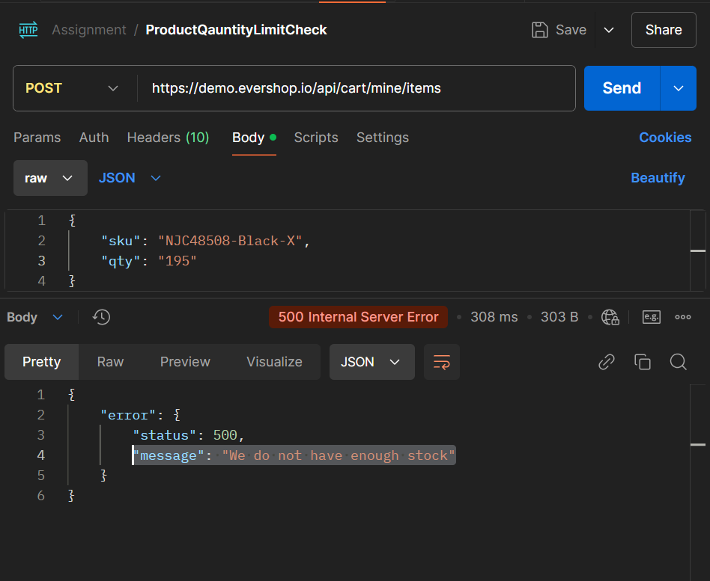

* ***Analysis:*** Both UI and API end showed error in this scenario.